**Tutorial: Organizing your Files**

Right now, all the files of our site are in the same folder. But we really should organize things a little better.

**This tutorial uses the previously completed AwesomeCo. If you want to follow along, open all three .html pages and the style.css in your text editor.**

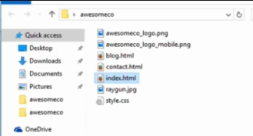

Let's create an `images` folder and a `stylesheets` folder

**Right click on the Windows Explorer and select “New” – “Folder”.**

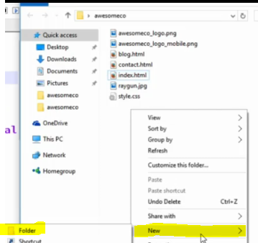

**Rename the folder “images”.**

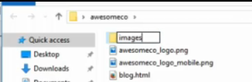

**Right click on the Windows Explorer and select “New” – “Folder”.**

**Rename the folder “stylesheet”.**

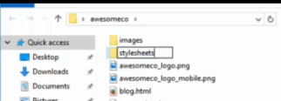

We'll then move our stylesheet and our image into the respective folders.

**Drag the style.css into the stylesheets folder.**

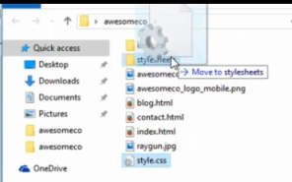

**Drag the images into the images folder.**

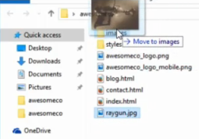

Of course, this breaks a bunch of things because now our images are missing and our stylesheet isn't working.

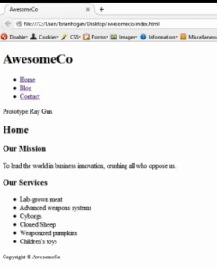

So first, we have to fix the reference to the stylesheet in our HTML page.

It's in the `stylesheets` folder now, so we have to put the folder name in front of the stylesheet path. We have to tell the browser to look in the stylesheets folder for that stylesheet now. Without a folder name in the path the browser just looks for the stylesheet in the same folder that this web page is in. Remember that we have to use a forward slash to separate folder names and filenames. `stylesheets` is the folder, and `style.css` is the file.

**Add *stylesheets/* to the link tag href on the index.html page.**

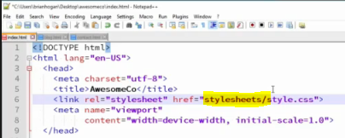

**Save the index.html page and refresh.**

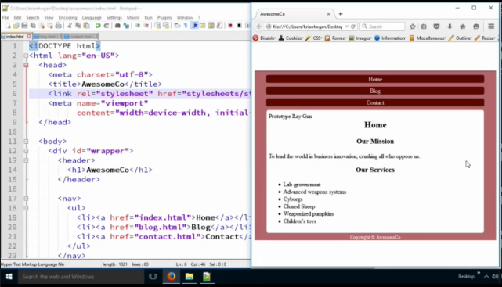

Next, to make the ray gun image show up, we have to tell the browser to look in the `images` folder, so we change the image source path to look in that `images` folder. We do the same thing here:

**Add *images/* in front of the image name.**

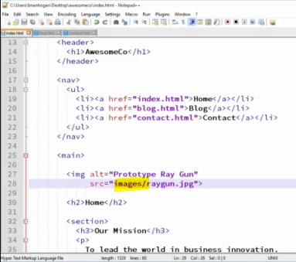

**Save the index.html page and** **refresh**.

Things start to look great, but where's our logo?

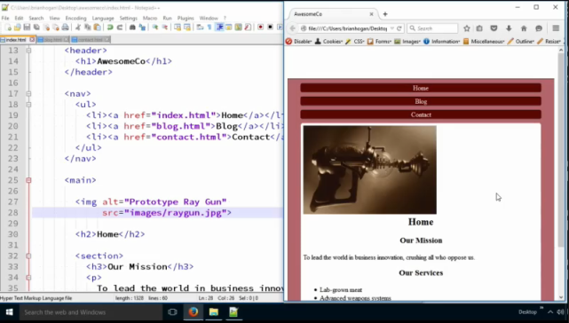

Well, remember that we also loaded an image in our stylesheet, so let's go there and adjust the path.

The stylesheet is now in the `stylesheets` folder, and so it's looking for the awesomeco logo in the stylesheets folder. We have to tell it to look in the images folder, which is one folder up and then down into the images folder.

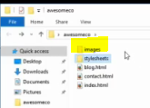

So, in front of the image name, we do a dot-dot slash for up one folder and then we specify the images folder and another slash. That gives the browser the relative path it needs to find things. This page is in the stylesheets folder, so we go up one folder, then down into the images folder, and then we find the images file.

**Add *../images* to the background-image: url path towards the top of the .CSS document.**

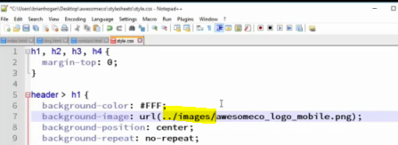

Remember that we have two images in here, so we have to do this for both.

**Add *../images* to the background-image: url path in the desktop media query.**

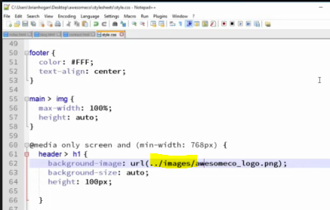

And now our page looks exactly like it should again, but our site is much more organized. We know where our CSS is and we know where our images are.

**Save the style.css file and refresh the index.html page.**

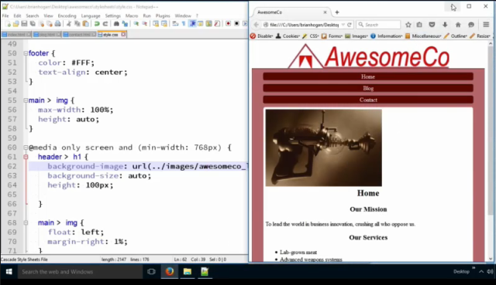

Don't forget - we have to make the changes to our other pages in the site as well. The stylesheet link will definitely need to change there. I'll leave that up to you to fix.

Site organization is incredibly important once you get a lot of images and other files.